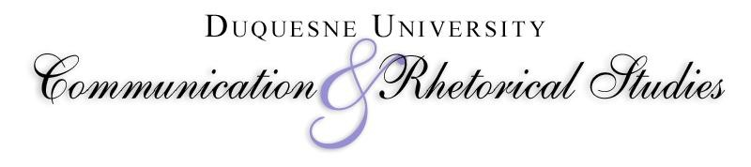

*Walking the Humanities into the Marketplace The Ethical Difference*



**17th Biennial**

**Communication Ethics Conference:**

***Communication Ethics as Tenacious Hope***

# Sponsored by the

**Department of Communication & Rhetorical Studies and the Communication Ethics Institute at Duquesne University**

**June 6–8, 2023**

**All times are according to U.S. Eastern Time (ET).**

## Ronald C. Arnett and Tenacious Hope

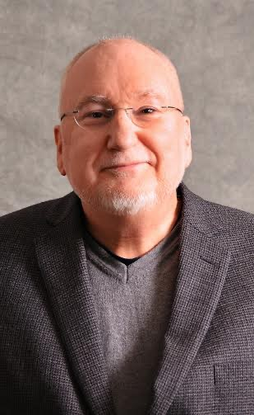As is evident from a glance at this program, we have organized the 17th Biennial Communication Ethics Conference around themes characterizing the work of

Ronald C. Arnett (Ph.D., Ohio University, 1978), now

Professor Emeritus of the Department of

Communication & Rhetorical Studies. The conference focus, “Communication Ethics as Tenacious Hope,” takes its title from his latest award-winning book, *Communication Ethics and Tenacious Hope: Contemporary Implications of the Scottish Enlightenment* (2022, SIU Press). Our purpose is to honor his work and legacy in a way consistent with his commitment to the value of work and ideas. We offer thanks to Ronald C. Arnett for his tenacious hope, which formed the foundation for the renewal of this department almost 30 years ago and provided the impetus for the development of the Rhetoric Ph.D. program two decades ago.

Ronald C. Arnett was the Patricia Doherty Yoder and Ronald Wolfe Endowed Chair in Communication Ethics (2015–2022) and the Henry Koren, C.S.Sp., Endowed Chair for Scholarly Excellence (2010–2015) at Duquesne University. He has co-edited seven books and authored/coauthored twelve books.He is the recipient of nine book awards, including the 2022 Top Book Award (NCA’s Communication Ethics Division, *Communication Ethics and Tenacious Hope: Contemporary Implications of the Scottish Enlightenment*), the 2017 Top Book Award and 2017 Distinguished Book Award (NCA’s Communication Ethics Division and Philosophy of Communication Division, *Levinas’s Rhetorical Demand: The Unending Obligation of Communication Ethics*), and the 2013 Top Book Award (NCA’s Communication Ethics Division, *Communication Ethics in Dark Times: Hannah Arendt’s Rhetoric of Warning and Hope*). In 2017, he was named Distinguished Scholar by the National Communication Association. He is the recipient of the 2013 Presidential Award for Excellence in Scholarship from Duquesne University and is the recipient of the 2005 Scholar of the Year Award from the Religious Communication Association. Arnett was named Centennial Scholar of Communication and Centennial Scholar of Philosophy of Communication by the Eastern Communication Association in 2009 and received its Distinguished Service Award in 2019. Arnett has completed three editorships for the *Journal of Communication and Religion* and is the former editor of the *Review of Communication*. He has also served as the Executive Director of the Pennsylvania Communication Association, Executive Director of the Eastern Communication Association, and President of the Semiotic Society of America.

1

## Ronald C. Arnett and Tenacious Hope

The metaphor of tenacious hope appears in many of Arnett’s works. For Arnett, tenacious hope “lives in the actions of those who do not cease laboring and struggling for change— no matter the obstacles or difficulties” (Arnett, 2015, p. 262). Tenacious hope “opens the world to work that requires participation without guarantee of outcome” (Arnett, 2015, p. 4). Tenacious hope counteracts consumeristic optimism, which expects the world to meet one’s expectations and demands for the future. Optimism anticipates that “all will work out on its own,” ignoring the command of reality to participate and labor for new possibilities. In contrast, tenacious hope propels one to roll up one’s sleeves and walk through the “mud of everyday life” with others (Arnett & Arneson, 1999, p. 32). Tenacious hope recognizes a responsibility to labor for what matters, even if all efforts resemble the absurd akin to Sisyphus pushing his rock up a mountain only to watch it roll down again (Arnett, 2020; Camus, 1955): “Somehow, human beings put one foot in front of another with a ‘tenacious hope’ . . . that meaning will eventually resurface from a given moment of eclipse” (Arnett, 2020, p. 6). Tenacious hope flips absurdity on its head, finding opportunity to move in a positive direction despite incomprehensible conditions. Tenacious hope has implications for dialogue, existential homelessness, and communication ethics.[1]

**References**

Arnett, R. C. (2015). Communicative meeting: From Pangloss to tenacious hope. In P. J. Gehrke & W. M. Keith (Eds.), *A century of communication studies: The unfinished conversation* (pp. 261–285). New York: Routledge.

Arnett, R. C. (2020). Communication pedagogy: The coronavirus pandemic. *Journal of Communication Pedagogy*, *3*, 5–10.

Arnett, R. C., & Arneson, P. (1999). *Dialogic civility in a cynical age: Community, hope, and interpersonal relationships*. Albany: State University of New York Press.

Camus, A. (1955). *The myth of Sisyphus* (J. O’Brien, Trans.). New York: Vintage Books.

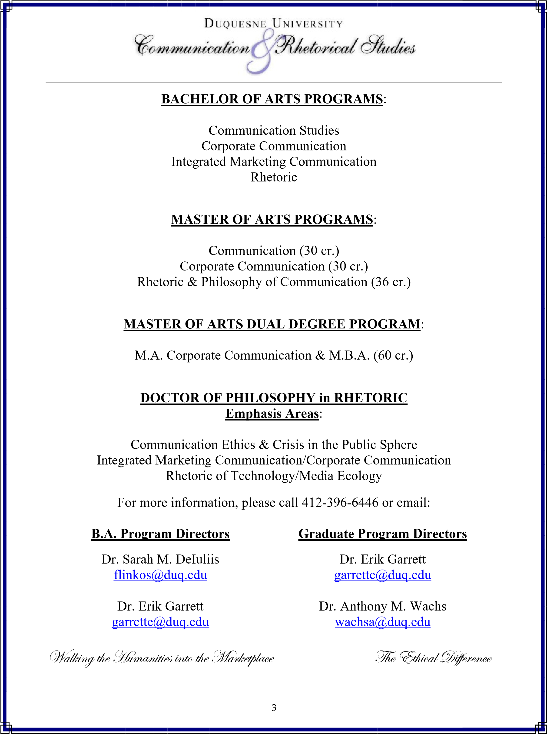

## Program at a Glance

|  |  |  |
| --- | --- | --- |
| **Day 1: Tuesday, June 6** | **Day 2: Wednesday, June 7** | **Day 3: Thursday, June 8** |
| **8:30–9:00 AM** **Opening Blessing**  **& Conference Welcome** | **8:45 AM**  Zoom link opens | **8:45 AM**  Zoom link opens |
| **9:00–10:00 AM**  **Keynote Address: Amit Pinchevski**  “Beyond Dialogue:  Communication Ethics Between  Interpersonal and Impersonal” | **9:00–10:15 AM** **Session 4** 4A: Communication Ethics in the Classroom    4B: Communication Media  Ethics | **9:00–10:15 AM Session 7** 7A: Arnett, Tenacious Hope,  and the Unity of Contraries    7B: Communication Ethics and  Marshall McLuhan |
| **10:15–11:45 AM Session 1**  1A: A Unique Voice: An African  American Perspective of  Tenacious Hope as  Communication Ethics    1B: Communication Ethics and the Vulnerable Other    1C: Communication Ethics and Jordi Pujol’s (2023) *The Collapse of Freedom of Expression:*  *Reconstructing the Ancient Roots of Modern Liberty* | **10:30–11:30 AM**  **Keynote Address:**  **Özüm Üçok-Sayrak**  “Tenacious Hope in Hollow  Modernity: Respiratory  Revelations” | **10:30–11:30 AM Keynote Address:**  **Timothy Sellnow**  “Dialogic Civility as the  Measure of a Life Well-Lived” |
| **12:00–1:15 PM Session 2**  2A: Communication Ethics:  Tenacious Hope in a Digital Age    2B: Rhetoric, Philosophy of  Communication, and  Communication Ethics in the  Mud of Everyday Life I    2C: 4C: Being in Higher  Education: Community,  Culture, and Care as Hesed | **11:45–1:15 PM** **Session 5**  5A: Rhetoric, Philosophy of  Communication, and  Communication Ethics in the  Mud of Everyday Life II    5B: Dialogic Ethics of Self and  Other | **11:45–1:15 PM Session 8** 8A: Narratives and Metanarratives of Truth, Goodness, and Beauty:  Considering the Work of Ronald  C. Arnett    8B: Communication Ethics in  Politics and Public Argument |
| **1:30–2:45 PM Session 3**  3A: Dialogic Administration I    3B: Tenacious Hope in  Communication Ethics  Pedagogy | **1:30–2:45 PM** **Session 6**  6A: Dialogic Administration II    6B: Interchanges of  Responsibility: Practicing and  Inspiring Ethical Rhetoric | **1:30–2:45 PM** **Session 9**  9A: Dialogic Administration III    9B: Communication Ethics,  Organizations, and Marketing |
| **2:45–3:00 PM**  **Day 1 Closing** | **2:45–3:00 PM**  **Day 2 Closing** | **2:45–3:00 PM**  **Conference Closing** |

**TUESDAY**

**JUNE 6, 2023**

Zoom Link

Meeting ID: 958 3566 9643

Passcode: CEC2023

### 8:30 – 9:00 AM Opening Blessing & Conference Welcome

Fr. Bill Christy, C.S.Sp., *Director of Campus Ministry and*

*University Chaplain*

Janie M. Harden Fritz, *Chair, Department of Communication &*

*Rhetorical Studies*

Dean Kristine Blair, *McAnulty College and Graduate School of*

*Liberal Arts*

### 9:00 – 10:00 AM Beyond Dialogue: Communication Ethics Between Keynote Interpersonal and Impersonal

Amit Pinchevski, *The Hebrew University of Jerusalem*

In this talk, I offer preliminary thoughts toward rethinking communication ethics beyond dialogue and otherwise than the duality of interpersonal and impersonal. To that end, I suggest the concept of “thirdness,” which I argue allows for the reconsideration of communication ethics both within and outside dialogue. Ronald C. Arnett’s idea of “dialogic civility” will serve as a starting point for the discussion, following a brief review of different configurations of thirdness. I then turn to Emmanuel Levinas’s account of the Third as instructive of the necessary tension of attending both to the particular and the universal, the close-by and the far-off, indeed, the interpersonal and the impersonal. Thirdness calls for reason and justice as the continuation of responsibility by different means, while responsibility continues to bear on reason and justice, steering them away from abstraction. Levinas’s style of writing in his later work provides an example for such an ethical discourse, and, if time permits, I will try to speculate about extending it further.

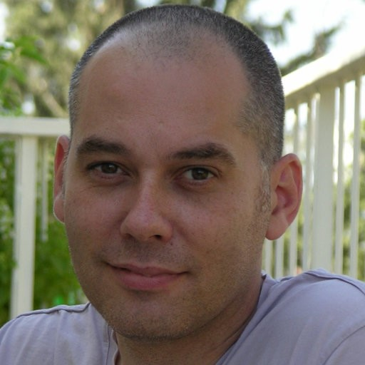**Amit Pinchevski**, Ph.D., is a Full Professor in the Department of Communication and Journalism at the Hebrew University of Jerusalem, Israel, where he has been teaching since 2004, after completing his doctoral research at McGill University, Canada. His research interests are in theory and philosophy of communication and media, focusing specifically on the ethical aspects of the limits of communication; media witnessing, memory and trauma; and pathologies of communication and their construction. Dr. Pinchevski is the author of *By Way of Interruption: Levinas and the Ethics of Communication* (Duquesne UP, 2005), *Transmitted*

*Wounds: Media and the Mediation of Trauma* (Oxford UP, 2019), and *Echo* (MIT Press, 2022). He is coeditor of *Media Witnessing: Testimony in the Age of Mass Communication* (with P. Frosh; Palgrave, 2009) and *Ethics of Media* (with N. Couldry and M. Madianou; Palgrave, 2013). His work has appeared in academic journals such as *Critical Inquiry*, *Philosophy and*

*Rhetoric*, *Cultural Critique*, *Cultural Studies*, *Public Culture*, *New Media & Society*, and *Theory, Culture & Society*.

In 2011, he was a Visiting Scholar at the Annenberg School for Communication at the University of Pennsylvania, and in the following year the recipient of the James A. Jaksa Scholar Award from the National Communication Association’s Communication Ethics Division. From 2011–2015, he served as Vice-Chair and Chair of the Philosophy, Theory and Critique Division of the International Communication Association. He is a former Senior Fellow of the Martin Buber Society of Fellows at the Hebrew University, later serving as a member of the Society’s academic committee.

**10:15 – 11:45 AM** **Breakout Room 1A**

**A Unique Voice: An African American Perspective of**

### Tenacious Hope as Communication Ethics

Chair: William Burgess, *Gallaudet University*

“AfroFuturism”

Nate Cox, *Duquesne University*

“Lamenting Hope”

Richard Wingfield, *Duquesne University*

“Call and Response”

Rodney Lyde, *Duquesne University*

“Leadership”

Victor Grigsby, *Duquesne University*

“Soul and Reconciliation”

William Burgess, *Gallaudet University*

### 10:15 – 11:45 AM Breakout Room 1B Communication Ethics and the Vulnerable Other

Chair: Michael Kearney, *Duquesne University*

“Communication Ethics in Gail Jones’ Sorry”

Marietta Kosma, *Oxford*

“Reclaiming Identity and Transforming Community: Ethical Communication Practices in the Work of

Biracial Asian-American Artist Nancy Valentine”

David Beard, *University of Minnesota Duluth*

Ryan Goei, *University of Minnesota Duluth*

“Economic Success or Human Health during the COVID-19 Pandemic: Ethical Choices and the Role of

Essential Worker Safety in the Meatpacking Industry”

Jeffrey D. Brand, *University of Northern Iowa*

**10:15 – 11:45 AM Breakout Room 1C**

### Communication Ethics and Jordi Pujol’s (2023) *The Collapse of*

***Freedom of Expression: Reconstructing the Ancient Roots of Modern Liberty***

Chair: Natalia E. Tapsak, *Duquesne University*

“‘Defending Freedom of Expression but Not Its Content’: Secularization, Extremism, and Freedom of Speech”

Lina Erekat, *Duquesne University*

### (cont.)

“Liberty and Learning: Change from Founding Fathers to Faltering Foundations in Liberal Education”

Joshua Clements, *Duquesne University*

“’The Rise of the New Orthodoxy’: Freedom of Speech and Protected Expression”

Preston Carmack, *Duquesne University*

“‘A Fabricated Notion of Tolerance’: Social Order, Morality, and Dialogic Civility”

Kristen Haldeman, *Duquesne University*

“‘The Neutrality of the Public Space’: Creation of the Public Sphere”

Drew Connolly, *Duquesne University*

“‘Reframing Freedom of Expression as a Human Good’: Equality, Reasonability, and Responsibility”

Andri Kosasih, *Duquesne University*

“’Repairing the Relationship between the Secular and the Sacred’: Faith and Reason”

Natalia E. Tapsak, *Duquesne University*

### 12:00 – 1:15 PM Breakout Room 2A

**Communication Ethics: Tenacious Hope in a Digital Age**

Chair: Abbey McCann, *Duquesne University*

“Influencers and Communication Ethics: The Exhibition of Perfection”

Abbey McCann, *Duquesne University*

“AI and Philosophy of Communication in Ovid and Cyrano de Bergerac”

Matthew S. Lindia, *Duquesne University*

“Ethics in the Age of Mechanical Reproduction”

Alex Fagin, *Duquesne University*

“Ethics in Advertising: The Role of Communication Ethics in Big-Data-Driven Digital Advertising

Practices”

Michele M. Wisnesck, *Duquesne University*

### 12:00 – 1:15 PM Breakout Room 2B Rhetoric, Philosophy of Communication, and Communication Ethics in the Mud of Everyday Life I

Chair: Sarah M. DeIuliis, *Duquesne University*

“Corporate Communication Leadership and Ethics in the Mud of Everyday Life”

Fr. Lazarus Langbiir, *Duquesne University*

### (cont.)

“Communication Ethics Literacy and Leadership: Navigating the Mud of Nonprofit Work”

Hannah Karolak, *The Forbes Funds*

“Art & The Mud of Everyday Life: The Commonplace Object in Warhol’s Visual Philosophy of

Communication Ethics”

Sarah M. DeIuliis, *Duquesne University*

“Doing Philosophy of Communication Scholarship in the Mud of Everyday Life”

Susan Mancino, *Saint Mary’s University*

Michael R. Kearney, *Duquesne University*

### 12:00 – 1:15 PM Breakout Room 2C Community, Culture, and Care as Hesed

**Being in Higher Education:**

Chair: Marie Baker-Ohler, *Northern Arizona University*

“Walking Arnettian Metaphors into the 2023 Classroom: Holy Sparks in This Historical Moment”

Marie Baker-Ohler, *Northern Arizona University*

“Pragmatic Praxis: Modeling Communication Ethics as Reflection and Action”

Melissa Cook, *Washington & Jefferson College*

“The Tenacious Hope for Meaning and Value amid Struggles at the Intersection of Higher Education and the Marketplace: Toward a Narrative Dialogic Ethic of Self-Overcoming John Prellwitz, *University of Pittsburgh at Greensburg*

**1:30 – 2:45 PM** **Breakout Room 3A**

### Dialogic Administration I

Chair: Özüm Üçok-Sayrak, *Duquesne University*

“Dialogic Administration: A Communication Approach to Effective 21st-Century Leadership”

Tim Brown, *Montgomery County Community College*

“The Role of a-Muse in Dialogic Administration”

Kristen Majocha, *University of Nebraska at Kearney*

“Dialogic Administration and Servant Leadership”

Tricia Gianonne McFadden, *Saint Francis University*

“The Dialogic Administration of Hope in Transcending Crises”

Timothy Sellnow, *University of Central Florida*

Deanna Sellnow, *University of Central Florida*

Jessica Hoffman, *University of Central Florida*

### 1:30 – 2:45 PM Breakout Room 3B

**Tenacious Hope in Communication Ethics Pedagogy**

Chair: Preston Carmack, *Duquesne University*

“The Communion Between Goodness and Fallibility: What Ricoeur’s Understanding of Fallibility

Contributes to Communication Ethics Pedagogy”

Preston Carmack, *Duquesne University*

“Pedagogy in the Workplace: Enacting Response-ability for Corporate and Personal Transformation”

Kristen Haldeman, *Duquesne University*

Shawn Wolf, *Regent University*

“Narrative Ground in Public Speaking: Ronald C. Arnett on the Basic Communication Course”

Michael Kearney, *Duquesne University*

Rodney Lyde, *Duquesne University*

“Listening versus Hearing: Critical Engagement with Difference in the Classroom through Freire’s

Critical Pedagogy and Communication Ethics”

Carla Rae Richards, *Duquesne University*

### 2:45 – 3:00 PM Day 1 Closing

**WEDNESDAY**

**JUNE 7, 2023**

Zoom Link

Meeting ID: 958 3566 9643

Passcode: CEC2023

### 9:00 – 10:15 AM Breakout Room 4A Communication Ethics in the Classroom

Chair: Natalia E. Tapsak, *Duquesne University*

“’Hot Eloquence’: Communicative Ethics in Dewey’s Observations of Chinese Student Activism”

Jeremiah Dyehouse, *University of Rhode Island*

“Hope and Tragic Sensibility in Ambedkar’s Navayana Pragmatist Rhetoric”

Scott R. Stroud, *University of Texas, Austin*

“Community of Inquiry: A Pedagogy of and for Democracy”

Keisha Christle A. Abog, *University of the Philippines, Los Baños*

“Resilience Building in Classroom beyond Breathing-In & Breathing-Out”

Andrea C. Valente, *York University*

### 9:00 – 10:15 AM Breakout Room 4B Communication Media Ethics

Chair: Preston Carmack, *Duquesne University*

“Fact-checking and Citizenship: Media Ethics and Digital Media Literacy”

Paulo Barroso, *Polytechnic Institute of Viseu*

“The Role of the Mass Media in Cultural Perception”

Jamila Farajova, *University of Santiago de Compostela*

“Ethical Questions Raised by AI-assisted Personal and Collective Storytelling”

Helga Lenart-Cheng, *Saint Mary's College of California*

**10:30 – 11:30 AM Tenacious Hope in Hollow Modernity:**

**Keynote** **Respiratory Revelations**

Özüm Üçok-Sayrak, *Duquesne University*

Multiple themes from Ronald C. Arnett’s scholarship, including derivative agency, attentiveness, existential homelessness, and his critique of individualism, point to a meta-theme that is at the heart of his work: the revelatory. This presentation highlights Arnett’s discussion of tenacious hope as a revelatory phenomenon in connection to this historical moment, which I distinguish as hollow modernity—a moment following Bauman’s liquid modernity. Hollow modernity is characterized by disembodied presence, excess of stimuli, and loss of freedom of attention and empathy that feed thoughtlessness. I discuss ethics of attention as an integral part of scholarship on communication ethics that is connected to the revelatory. Finally, I offer initial sketches of a respiratory philosophy of communication ethics that reveals the world by attending to breathing-*with* as our most intimate and elemental (co-)participation in the world and in connection to tenacious hope that emerges at the limits of thinking, knowing, and hoping.

**Özüm Üçok-Sayrak**, Ph.D., is Associate Professor at the Department of Communication & Rhetorical Studies at Duquesne University. Her research interests include communication ethics, aesthetic communication, philosophy of communication, ethics and epistemology, and contemplative education.

Dr. Üçok-Sayrak is the author of *Aesthetic Ecology of*

*Communication Ethics: Existential Rootedness* (Fairleigh Dickinson UP, 2019). She has published papers on communication ethics and culture; embodiment, health, and selfhood; mindfulness;

and aesthetic communication. Her work has appeared in scholarly journals such as *Review of Communication,* *Journal of International and Intercultural Communication*, *Human Studies, Atlantic Journal of Communication, Symbolic Interaction,* and in several edited books.

### 11:45 AM – 1:15 PM Breakout Room 5A Ethics in the Mud of Everyday Life II

**Rhetoric, Philosophy of Communication, and Communication**

Chair: Matthew P. Mancino, *Indiana University South Bend*

“Souls of Fire: Ronald C. Arnett, Howard Thurman, and Prophetic Rhetoric”

William Burgess, *Gallaudet University*

“Situating the Self in the Mud of Everyday Life”

Basak M. Guven, *Duquesne University*

“Existentialist Communication Ethics in the Mud of Everyday Life”

Matthew P. Mancino, *Indiana University South Bend*

**11:45 AM – 1:15 PM Breakout Room 5B**

### Dialogic Ethics of Self and Other

Chair: Garnet C. Butchart, *Duquesne University*

“Acknowledging Self and Other: An Analysis of Roman Reigns’s ‘Acknowledge Me’”

Paul Lucas, *University of Pittsburgh, Johnstown*

“Tenacious Attention: Listening against the Self in Philosophical Dialogue”

Lucy Elvis, *University of Galway*

“Lacan’s Relevance to Philosophically Driven Communication Ethics Research”

Garnet C. Butchart, *Duquesne University*

“Freedom, Sociability, and Responsibility in Emmanuel Levinas”

Dario Dellino, *University of Bari “Aldo Moro”, University “Carlo Bo”*

“Gadamerian Hermeneutics as Hopeful Listening”

Mike Jostedt, *St. Louis Community College- Florissant Valley*

**1:30 – 2:45 PM Breakout Room 6A**

### Dialogic Administration II

Chair: Janie M. Harden Fritz, *Duquesne University*

“Tender Ministrations”

Lisbeth Lipari, *Denison University*

“Promise and Forgiveness as Antidote to Existential Mistrust in Management”

Joel S. Ward, *Geneva College*

### (cont.)

“Mentoring and Dialogic Administration: The Role of Appreciative Listening”

Annette M. Holba, *Plymouth University*

Özüm Üçok-Sayrak, *Duquesne University*

“Dialogic Mentoring: Conversations in Context”

Janie M. Harden Fritz, *Duquesne University*

### 1:30 – 2:45 PM Breakout Room 6B Ethical Rhetoric

**Interchanges of Responsibility: Practicing and Inspiring**

Chair: Grace Walter, *Wayne State University*

“A Humanities-Focused Approach to Medical Composition and Communication” K.M. Begian-Lewis, *Wayne State University*

“Making Room for Accessible Composition”

Grace Williams, *Wayne State University*

“Rhetoric Gone Mad: Lessons from Disability Activist Publications”

Grace Walter, *Wayne State University*

“Ripping the Band-Aid Off: Examining the Failed Implementation of Culturally Relevant Pedagogy in

Higher Education”

Michael Jackson II, *Wayne State University*

### 2:45 – 3:00 PM Day 2 Closing

**THURSDAY**

**JUNE 8, 2023**

Zoom Link

Meeting ID: 958 3566 9643

Passcode: CEC2023

### 9:00 – 10:15 AM Breakout Room 7A

**Arnett, Tenacious Hope, and the Unity of Contraries**

Chair: Michael Kearney, *Duquesne University*

“From the *Coincidentia Oppositorum* to the Unity of Contraries: Reading Nicholas of Cusa Alongside

Ronald C. Arnett”

Michael Kearney, *Duquesne University*

“Intrinsic and Institutional Goods in Tension: Tenacious Hope for Universities”

David Impellizzeri, *Regent University*

“Performative: Wager for Communication Ethics as Tenacious Hope”

Fr. Nichodemus Okafor, *Duquesne University*

“Disinterested Help as a Medium of Tenacious Hope in a Humanitarian Crisis: Dialogic Analysis of

Volunteers’ Testimonies from the War in Ukraine”

Urszula Okulska, *University of Warsaw*

### 9:00 – 10:15 AM Breakout Room 7B Communication Ethics and Marshall McLuhan

Chair: Anthony Wachs, *Duquesne University*

“Dystopia’s Tetrad: Revisiting McLuhan’s Causal Analysis of Authoritarian Identity Quests”

Christopher S. Morrissey, *Trinity Western University*

“On Transfiguration: Belief and Perception in John Henry Newman and Marshall McLuhan”

Luigi Russi, *Campus de la Transition* & *ADEF Research Centre, University of Aix-Marseille*

“Retrieving ‘Soul-ology’ with McLuhan and Newman: Faculty Psychology as the Basis for a

Contemporary Communication Ethics”

Adam Pugen, *University of St. Thomas at Houston*

**10:30 – 11:30 AM Dialogic Civility as the Measure of a Life Well-Lived**

**Keynote** Timothy Sellnow, *University of Central Florida*

At the start of this century, Arnett and Arneson displayed remarkable prescience in their 1999 book, *Dialogic Civility in a Cynical Age*. They foresaw the growing cynicism that now threatens even the most revered elements of democracy. Later, Arnett articulately distilled messages of warning and opportunity in elaborate works interpreting the lessons of Hannah Arendt and Emmanuel Levinas. Combined, these works leave us with a blueprint for teaching and engaging in a form of dialogue particularly fitting for the dark times of risk and crisis. As one of Arnett’s first undergraduate students, I can say with confidence that Arnett’s tireless devotion to the scholarship and teaching on dialogic civility has, for four decades, given countless students and scholars a blueprint fitting not only for the academy but also for a life well-lived. This presentation navigates a few highpoints of Arnett’s explication of dialogic civility.

**Timothy L. Sellnow**, Ph.D., is a Professor of Strategic

Communication at the University of Central Florida (UCF). His research focuses on risk and crisis communication. He has conducted funded research for the Department of

Homeland Security, the United States Department of Agriculture, the Centers for Disease Control and Prevention, the Environmental Protection Agency, the United States Geological Survey, and the World Health Organization. He has also served in an advisory role for the National Academy of Sciences, the Federal Emergency Management Agency, the Centers for Disease Control and Prevention, and the Food and Drug Administration. He is past winner of the National Communication Association’s Gerald Phillips Award for

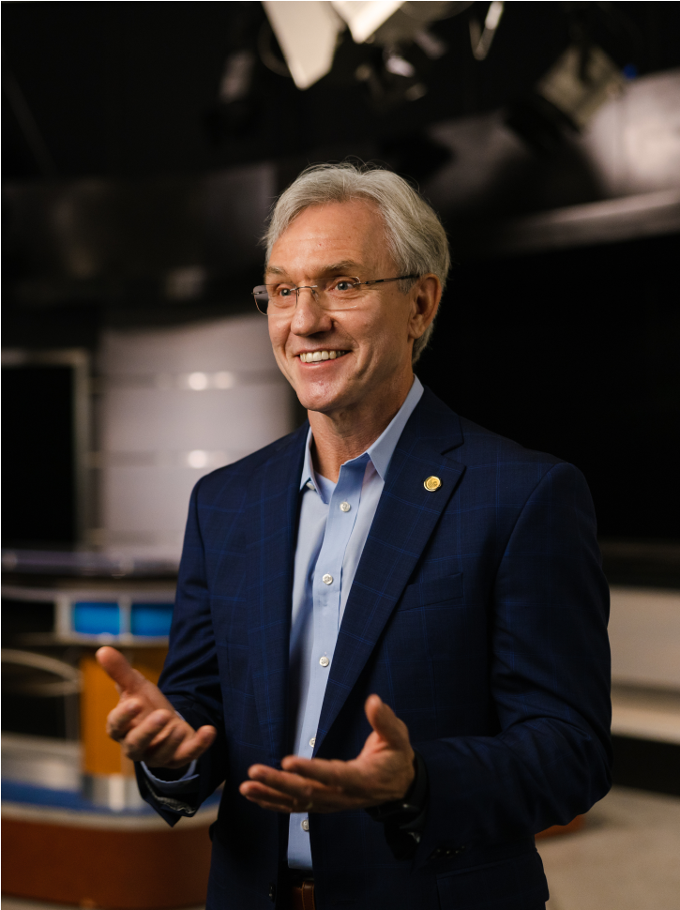

Distinguished Applied Communication Scholarship and UCF’s Luminary Scholar Award for research. He has coauthored six books on risk and crisis communication and has published many refereed journal articles. His most recent book is *Theorizing Crisis Communication* (2nd ed).

### 11:45 AM – 1:15 PM Breakout Room 8A Beauty: Considering the Work of Ronald C. Arnett

**Narratives and Metanarratives of Truth, Goodness, and**

Chair: N. Benton Parish, *Texas A & M University*

“The Metaphorical Significance of Dialogic Civility in the Arnettian Narrative”

Rev. John Amankwah, *Mount St. Joseph University*

“Narratives, Competing Goods, and the Critique of Liberalism”

Justin N. Bonanno, *Ave Maria University*

“Gently Confronting the Work of Ronald C. Arnett: Philosophical Realism and the Concept of Narrative”

Eric Grabowsky, *Dickinson State University*

“(Mis)attending to the Historical Moment: Arnett’s Postmodern Philosophy of Communication”

Anthony M. Wachs, *Duquesne University*

“Petite Narratives in the Metaverse: The Work of Ronald C. Arnett as Narrative Ground”

Joel S. Ward, *Geneva College*

### 11:45 AM – 1:15 PM Breakout Room 8B

**Communication Ethics in Politics and Public Argument**

Chair: Preston Carmack, *Duquesne University*

“The Physicist Steven Weinberg on the Moral Nature of Science and the Troublesome Presence of

Religion: A Case of Public Moral Argument”

Michael J. Hyde, *Wake Forest University*

“Ranciere and the Rhetorical: The Political Subject of the Contemporary Neurodiversity Movement”

Michael Vicaro, *Pennsylvania State University, Greater Allegheny Campus*

“Communication Ethics and Contemporary Disruptive Protest Speech: A Consideration of Space”

Andrew Tinker, *Pellissippi State Community College*

“Ethos and Responsibility”

Algis Mickunas, *Ohio University*

“The Deliberate Corruption of Environmental Advocates' Speech and Person, a Moment in the History of

Ideas, and a Problem in Ethical Theory”

Tom Duncanson, *Green Citizen Diplomacy Project*

**1:30 – 2:45 PM** **Breakout Room 9A**

### Dialogic Administration III

Chair: Annette M. Holba, *Plymouth University*

“Dialogue in the Utopian Standpoint: Compatible Habits of the Heart in Helmuth Plessner and Ronald C. Arnett”

Isaac E. Catt, *Duquesne University*

“In the Between: Leadership, Administration, and Managership”

Jen Jones, *Seton Hill University*

“Organizational Identity and Leadership: The Role of Mission in Dialogic Administration”

Susan Mancino, *Saint Mary’s College*

“Care and the Right-to-Die Debate”

Rachel Kaplan, *Pennsylvania State University*

“Between Dialogue and Dissemination: Ventriloquation as a Pragmatist Hope for This Hour”

François Cooren, *Université de Montréal*

### 1:30 – 2:45 PM Breakout Room 9B Communication Ethics, Organizations, and Marketing

Chair: N. Benton Parish, *Texas A & M University*

“Respect, Dialogue, and Innovation: Creating New Ideas and Solutions by Committing to an Ethical Culture”

N. Benton Parish, *Texas A & M University*

Michelle R. Darnell, *Pennsylvania State University*

“Knowledge Management Contributions to Organizational Conflict”

Sovi Herring, *Duquesne University*

“Ethical Values in Integrated Marketing Communication: An Analysis on Commercials”

Ayşe Müge Yazgan, *Marmara University*

Ebru Özgen, *Marmara University*

“Shifting Gender Appeal in Advertising”

Andrew Connolly, *Duquesne University*

### 2:45 – 3:00 PM Conference Closing

Janie M. Harden Fritz, *Duquesne University*

1. The bulk of this paragraph comes from a review of tenacious hope included in Tapsak, N. E. (2023). An icon of dialogic courage: Response to the absurd of the unity of contraries. *Atlantic Journal of Communication*. https://doi.org/10.1080/15456870.2023.2182438

  